**E-Commerce Website**

A

Minor Project Synopsis

Submitted in partial fulfilment of the requirement for the award of

Degree of

**Bachelor of Technology in Computer Science & Engineering**

Submitted to

**RAJIV GANDHI PROUDYOGIKI VISHWAVIDHYALAYA,**

**BHOPAL (M.P.)**



Submitted by

**JAY PATHAK (0131CS171025)**

**PRASHUK JAIN (0131CS171043)**

**RITESH KUMAR (0131CS171051)**

Under the Guidance of

**Prof. Megha Purohit Prof. Vijay Singh Pawar**

Head Of Department, CSE Asst. Prof. CSE

JNCT, Bhopal JNCT, Bhopal



**DEPARTMENT OF COMPUTER SCIENCE& ENGINEERING**

**JAI NARAIN COLLEGE OF TECHNOLOGY, BHOPAL**

**Session Jun-Nov 2019**

**JAI NARAIN COLLEGE OF TECHNOLOGY**

**Chouksey Nagar Berasia Road, Bhopal (M.P)**



**DECLARATION**

We hereby declare that the Minor Project titled “**E-Commerce Website**” is our own work conducted under the supervision of **Prof. Vijay Singh Pawar**, Department of Computer Science & Engineering, **Jai Narain College of Technology, Bhopal, M.P.**

**JAY PATHAK PRASHUK JAIN RITESH KUMAR**

**(0131CS171025) (0131CS171043) (0131CS171051)**

**JAI NARAIN COLLEGE OF TECHNOLOGY**

**Chouksey Nagar Berasia Road, Bhopal (M.P)**



**CERTIFICATE**

This is to certify that the minor project entitled “**E-Commerce Website**”, submitted to Rajiv Gandhi Proudyogiki Vishwavidyalaya, Bhopal (M.P.) by **Jay Pathak, Prashuk Jain, Ritesh Kumar** is a partial fulfillment of the requirement for the award of degree of Bachelor of Technology in Computer Science & Engineering. The matter embodied is the actual work done by **Jay Pathak , Prashuk Jain , Ritesh Kumar** is a record of bonafide work done by them under my supervision.

Guided By Approved By

**Prof. Vijay Singh Pawar Prof. Megha Purohit**

Computer Science & Engg. Head of Department

JNCT, Bhopal Computer Science & Engg.

JNCT, Bhopal

**CONTENTS**



A PROJECT REPORT 1

DECLARATION 2

CERTIFICATE 3

Introduction 5

Hardware & Software Requirement 9

Data Base Tables 10

Data Flow Diagram 11

E-R Diagram 12

Limitation 13

Future Enhancement 14

Conclusion 15

References 16

**INTRODUCTION**

**E-commerce** (**electronic commerce**) is the activity of [electronically](https://en.wikipedia.org/wiki/Electronically) buying or selling of [products](https://en.wikipedia.org/wiki/Product_(business)) on online services or over the Internet. Electronic commerce draws on technologies such as [mobile commerce](https://en.wikipedia.org/wiki/Mobile_commerce), [electronic funds transfer](https://en.wikipedia.org/wiki/Electronic_funds_transfer), [supply chain management](https://en.wikipedia.org/wiki/Supply_chain_management), [Internet marketing](https://en.wikipedia.org/wiki/Online_advertising), [online transaction processing](https://en.wikipedia.org/wiki/Online_transaction_processing), [electronic data interchange](https://en.wikipedia.org/wiki/Electronic_data_interchange) (EDI), [inventory management systems](https://en.wikipedia.org/wiki/Inventory_management_software), and automated [data collection](https://en.wikipedia.org/wiki/Data_collection) systems. E-commerce is in turn driven by the technological advances of the [semiconductor industry](https://en.wikipedia.org/wiki/Semiconductor_industry), and is the largest sector of the electronics industry.

Modern electronic commerce typically uses the [World Wide Web](https://en.wikipedia.org/wiki/World_Wide_Web) for at least one part of the transaction's life cycle although it may also use other technologies such as [e-mail](https://en.wikipedia.org/wiki/Email). Typical e-commerce transactions include the purchase of online books (such as [Amazon](https://en.wikipedia.org/wiki/Amazon_(company))) and music purchases ([music download](https://en.wikipedia.org/wiki/Music_download) in the form of [digital distribution](https://en.wikipedia.org/wiki/Digital_distribution) such as [iTunes Store](https://en.wikipedia.org/wiki/ITunes_Store)), and to a less extent, customized/personalized online [liquor store](https://en.wikipedia.org/wiki/Liquor_store) [inventory](https://en.wikipedia.org/wiki/Inventory) services. There are three areas of e-commerce: [online retailing](https://en.wikipedia.org/wiki/Online_retailing), [electronic markets](https://en.wikipedia.org/wiki/Electronic_markets), and [online auctions](https://en.wikipedia.org/wiki/Online_auction). E-commerce is supported by [electronic business](https://en.wikipedia.org/wiki/Electronic_business).

E-commerce businesses may also employ some or all of the followings:

* [Online shopping](https://en.wikipedia.org/wiki/Online_shopping) for [retail sales direct](https://en.wikipedia.org/wiki/Direct_selling) to consumers via [Web sites](https://en.wikipedia.org/wiki/Web_sites) and [mobile apps](https://en.wikipedia.org/wiki/Mobile_apps), and [conversational commerce](https://en.wikipedia.org/wiki/Conversational_commerce) via [live chat](https://en.wikipedia.org/wiki/Live_chat), [chatbots](https://en.wikipedia.org/wiki/Chatbot), and [voice assistants](https://en.wikipedia.org/wiki/Voice_assistants).
* Providing or participating in [online marketplaces](https://en.wikipedia.org/wiki/Online_marketplace), which process third-party [business-to-consumer](https://en.wikipedia.org/wiki/Business-to-consumer) (B2C) or [consumer-to-consumer](https://en.wikipedia.org/wiki/Consumer-to-consumer) (C2C) sales.
* [Business-to-business](https://en.wikipedia.org/wiki/Business-to-business) (B2B) buying and selling.
* Gathering and using demographic data through web contacts and social media.
* Business-to-business (B2B) [electronic data interchange](https://en.wikipedia.org/wiki/Electronic_data_interchange).
* Marketing to prospective and established [customers](https://en.wikipedia.org/wiki/Customer) by [e-mail](https://en.wikipedia.org/wiki/Email_marketing) or fax (for example, with [newsletters](https://en.wikipedia.org/wiki/Newsletter)).
* Online financial exchanges for currency exchanges or trading purposes.

**HOME PAGE**

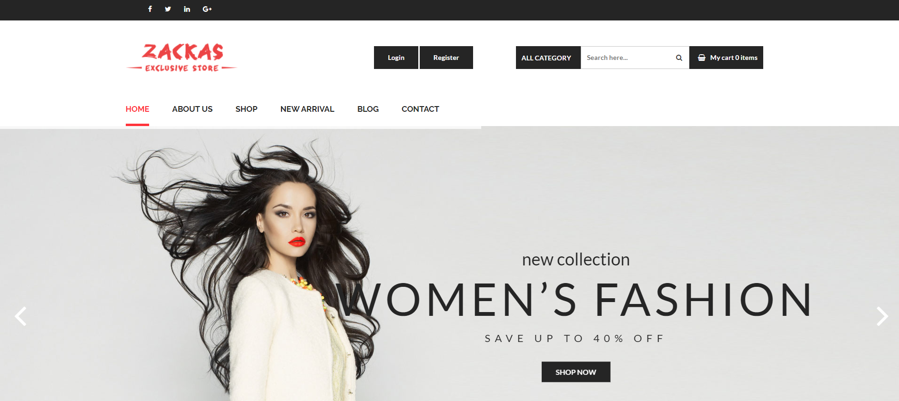

Register Button

Login Button

**LOGIN PAGE**

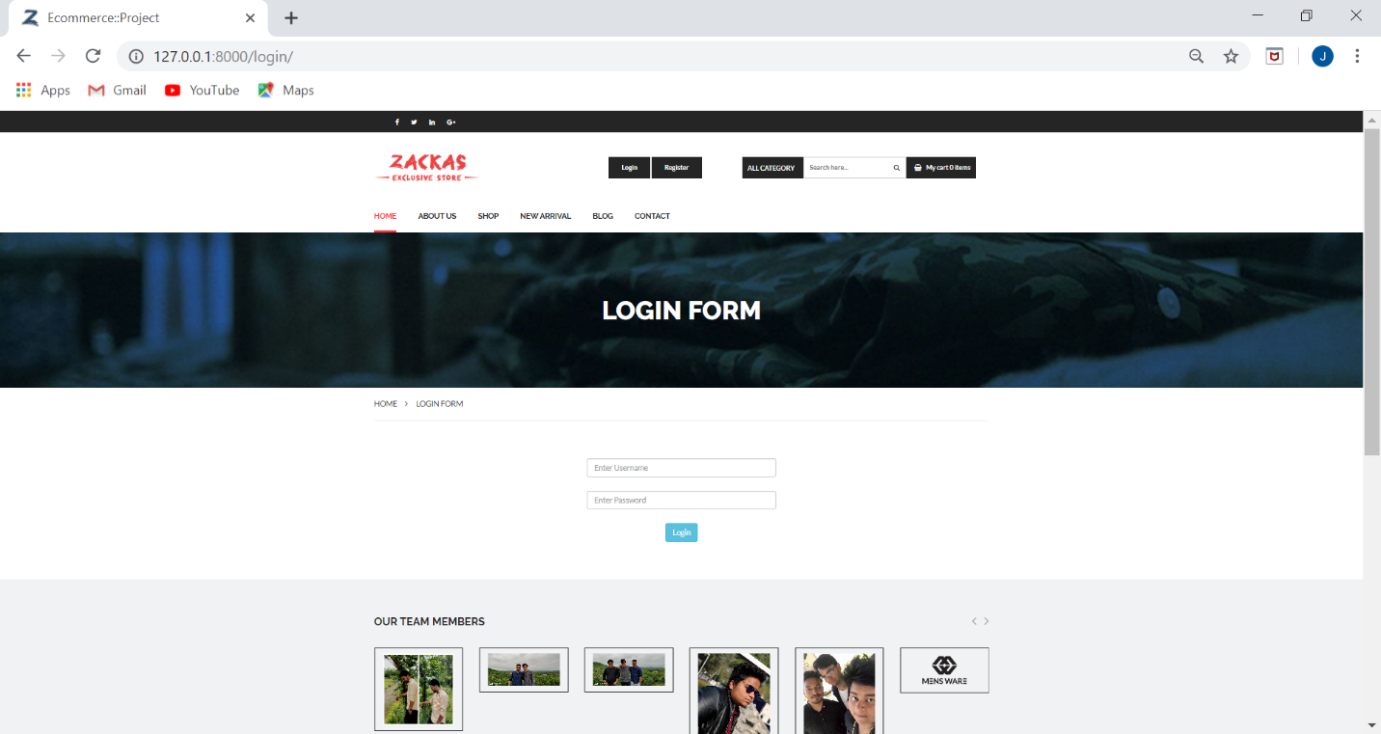A login is a set of credentials used to authenticate a user. Most often, these consist of a [username](https://techterms.com/definition/username) and [password](https://techterms.com/definition/password). However, a login may include other information, such as a PIN number, [passcode](https://techterms.com/definition/passcode), or [passphrase](https://techterms.com/definition/passphrase). Some logins require a [biometric](https://techterms.com/definition/biometrics) identifier, such as a fingerprint or retina scan.

**SIGN UP / REGISTER BUTTON**

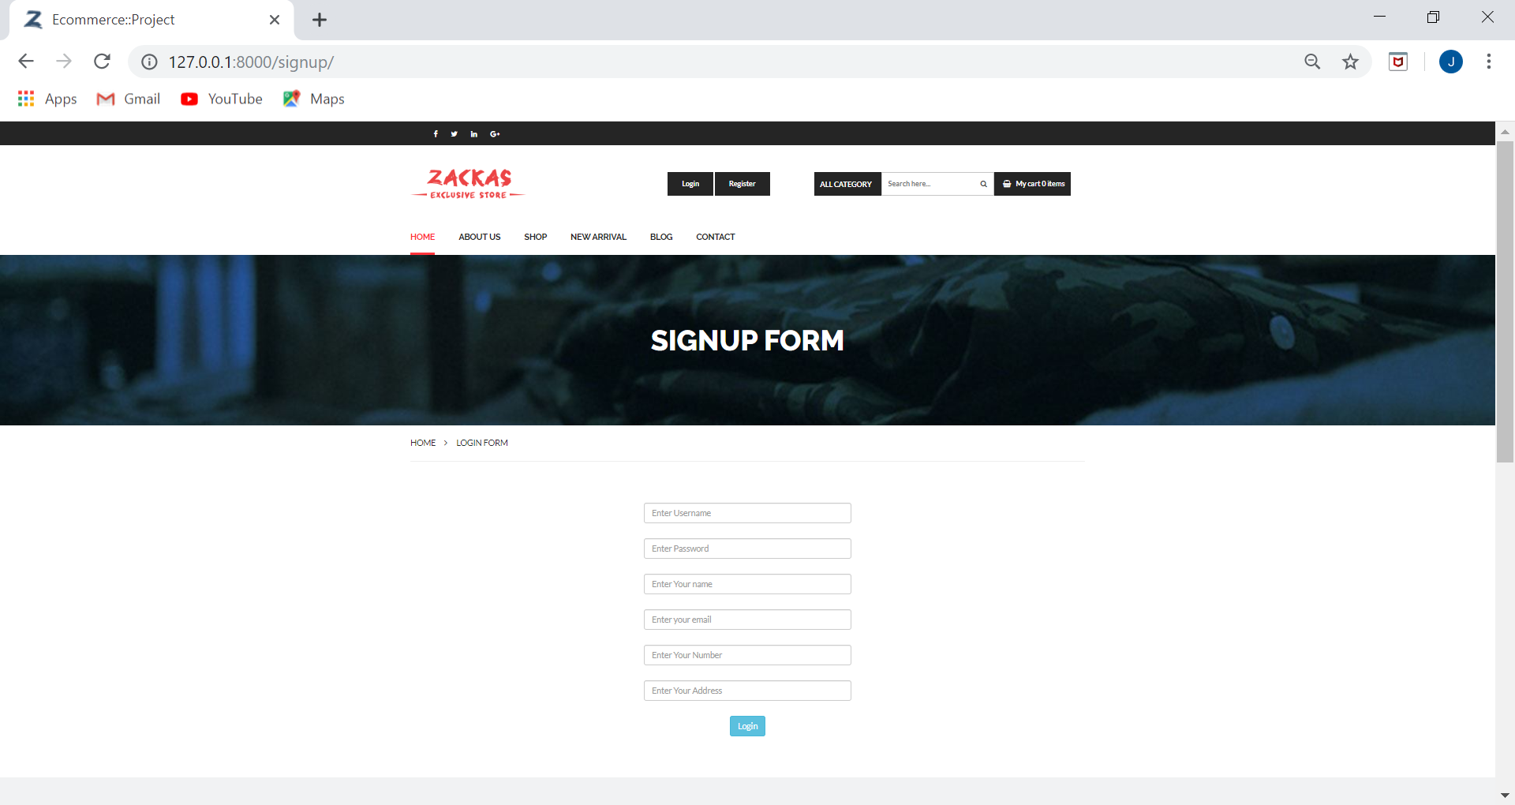A registration form is a list of fields that a user will input data into and submit to a company or individual. There are many reasons why you would want a person to fill out a registration form. Companies use registration forms to sign up customers for subscriptions, services, or other programs or plans.

**HARDWARE AND SOFTWARE REQUIREMENT**

**Hardware Requirement :-**

* Minimum 4 GB RAM
* Atleast 2 GB Hard Disk
* Pentium 4 Processor and onwards
* Screen resolution- 600 x 800

**Software Requirement:-**

* Windows XP, 7, 8, 10
* Oracle (My SQL) / SQLite3

**Reason:-**

It Facilitates in Handling queries & Helping developing good data base design

**Programming Languages:-**

* Python
* HTML 5
* CSS

**Reason:-**

It is a platform independent. It is a most demanding language in the present era.

**DATA BASE**

Database projects to create new databases, new data-tier applications (DACs), and to update existing databases and data-tier applications.

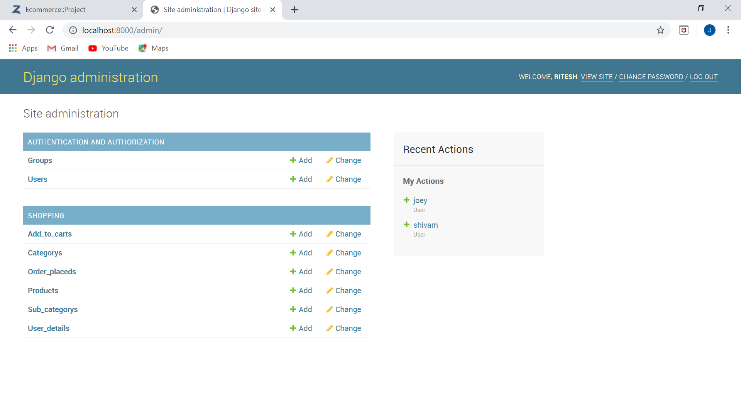Members of your team can then check out files to make, build, and test changes in an isolated development environment, or sandbox, before sharing them with the team.

**BLOCK DIAGRAM**

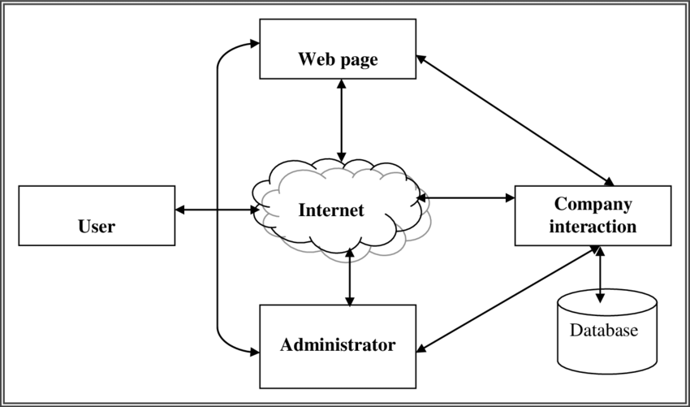

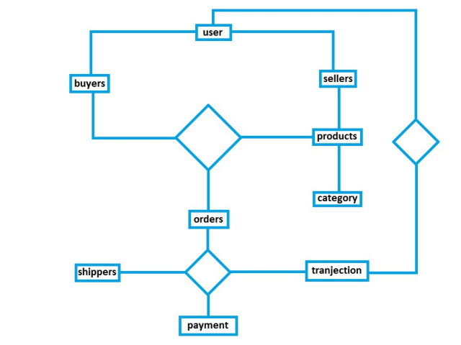**E-R DIAGRAM**

Transaction

**LIMITATIONS**

* **Security:** One of the main limitations of e-Commerce is security. In most cases, people are hesitant to provide their personal and financial details in spite of advanced data encryption security systems in place.
* **Huge Technological Cost: A** lot of money needs to be invested to be built up the technical infrastructure needed to run an e-Commerce business.
* **COD is not available:** Order can only placed with online transaction.
* **No return policy.**
* **Windows Based Website:** The following website is only applicable for Windows.

**FUTURE ENHANCEMENT**

1. Adding more secured payment gateways to secure the payment process.
2. Changing the database from sqlite3 to SQL so, that it will become easy to operate and become user friendly.
3. Making all the pages in the website , dynamic with it’s own URL.
4. Adding additional security like OTP Verification for odering any product from website.

**CONCLUSION**

* E-COMMERCE IS AN EVOLUTION.
* It is the best possible business in current market scenario.
* Low carrying cost of inventory.
* Paperless business process.
* The buyers has the opportunities to buy goods and services from all over globe.

**REFERENCES**

* [https://www.flipkart.com](https://www.flipkart.com/)
* [https://www.amazon.in](https://www.amazon.in/)
* [https://www.clubfactory.com](https://www.clubfactory.com/)
* [https://www.myntra.com](https://www.myntra.com/)
* <https://en.wikipedia.org/wiki/E-commerce>